
Generate reports using both MDX and Excel Pivot table for the following scenarios:
1. Display the standard cost of all the products along with their categories according to the regions in which they were sold. Which region is the most and the least expensive according to the result retrieved?

MIDX:
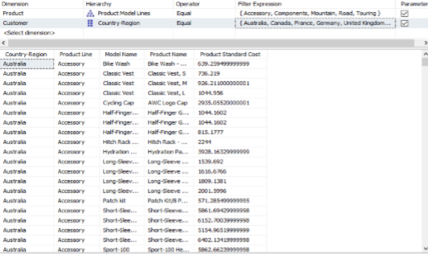

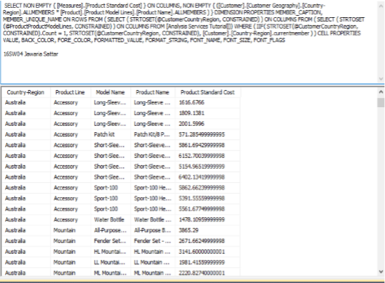
EXCEL Pivot Table:
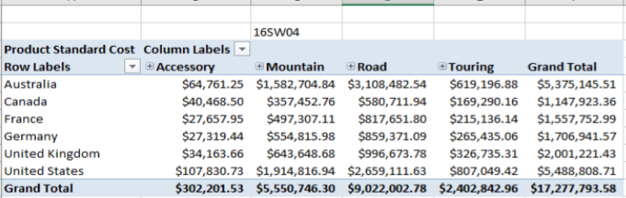
Results: Least expensive region: Canada Most expensive region: United States

Task2. Display the sales amount for all products (use product hierarchy) purchased according to the calendar year and filter the results according to the customers’ genders. What type of customers bought the most Biking products?

MDX:
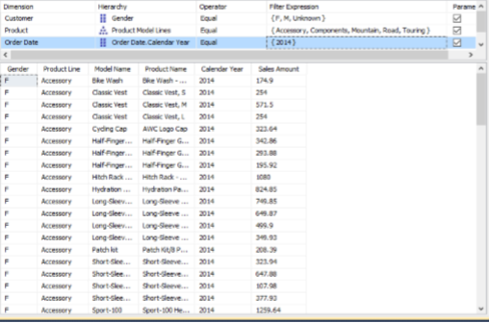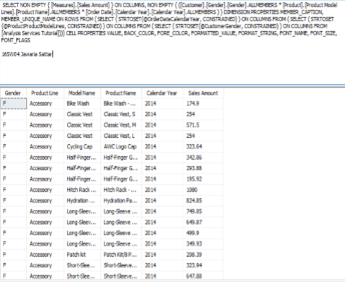
Excel Pivot Table:
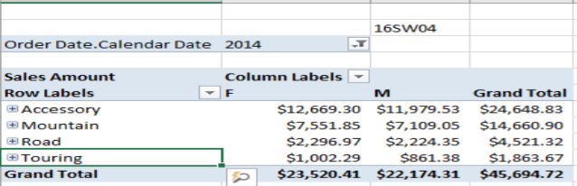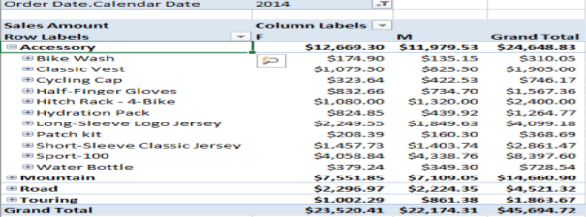
Results: Female customers bought the most Biking products

Task3:
Generate pivot charts for any 3 scenarios mentioned above to better visualize the data.
Display the standard cost of all the products along with their categories according to the regions in which they were sold. Which region is the most and the least expensive according to the result retrieved?
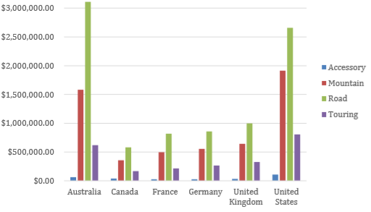
Display the Tax amount for customers according to their educations and occupations over calendar year. Do these factors impact the tax amount paid by a customer? Which class of customers pays the highest tax amount?
